**LAB 3**

TASK 1

INPUT

<!DOCTYPE html>

<html>

<head>

<body style="background-image:url(https://https://panel.000webhost.com/dashboard/814412/dashboard/public_html/photo/IMG_5059.jpeg; background-size:cover;>"</body>

</head>

<body>

<b><i><p style="color:green;background-color:lightgreen;font-size:50px;">Autumn in Tokyo</p></i></b>

<p stlye="font-size:50px;"><a href="https://www.sfu.ca">sfu</a></p>

<p style="font-size:50px;"><a href=https://www.yamahaboats.com">boat</a></p>

OUTPUT=

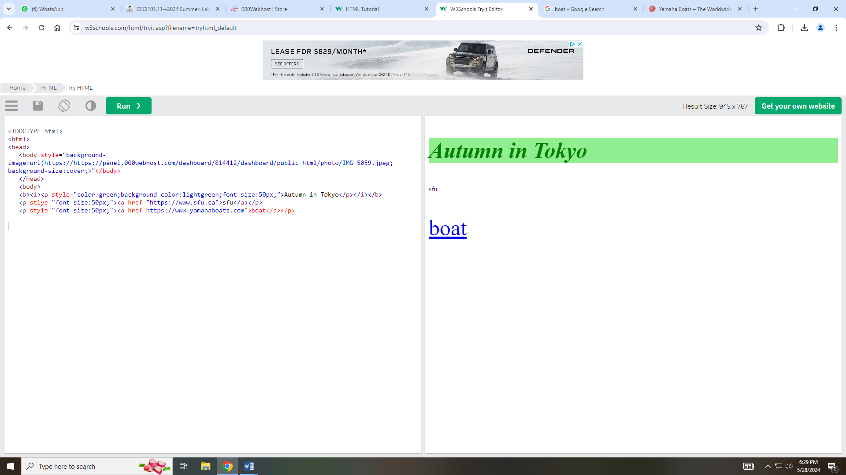

**Task 2**

INPUT=

<!DOCTYPE html>

<html>

<head>

<table style="width:100%" border=2>

</tr>

<th style="background-color: pink;">Name</th>

<th>Gender</th>

</tr>

</tr>

<td>Jaspreet Kaur</td>

<td>Female</td>

</tr>

</tr>

<td>Jenny</td>

<td>Female</td>

</tr>

<td>Tredau</td>

<td>Male</td>

<tr>

<td><img src="https://files.000webhost.com/handler.php?action=download?action=download&path=%2Fpublic_html%2Fphoto%2FIMG_5059.jpeg"width="70"height="70"></td>

<td>Vikrant</td>

</tr>

</table>

**OUTPUT=**

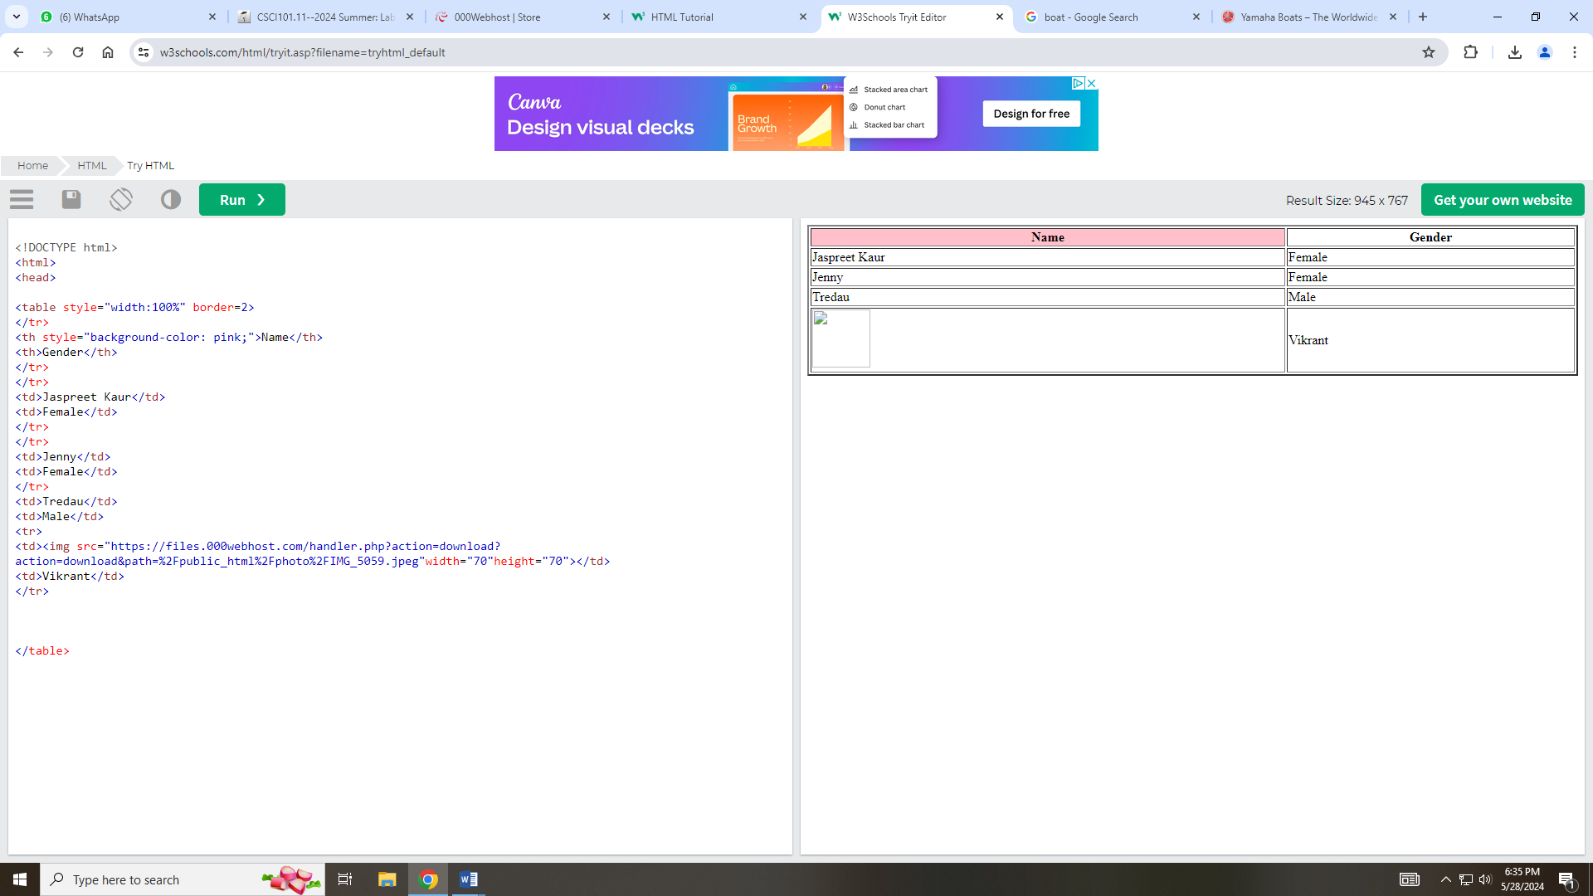

**Part 2**

Input=

<!DOCTYPE html>

<htm1> <body bgcolor="#90EE90"›

<a href="lion. jpg"›See lion picture</a>

<br>

<a href="https://www.pne.ca/"›Visit PNE website!</a>

<h1><font color="0000FF"> <h1›Hello‹/h1> <h2><font color="pink"› <h2>how are you?</h2> <h3><font color="white"›

<h3>Today is really sunny day.</h3> <table style "width:100%" border-2> <try <th></th>

<th›<img src="my.jpg" alt="vikrant Photo"style="width: 300px; height: 350px; "›</th> <th></th> < try <tr> <td><i>814412</td> <td><b>Jaspreet‹/b>‹/td> <td>Subscript‹/td> </tr> < table>

**Output**

